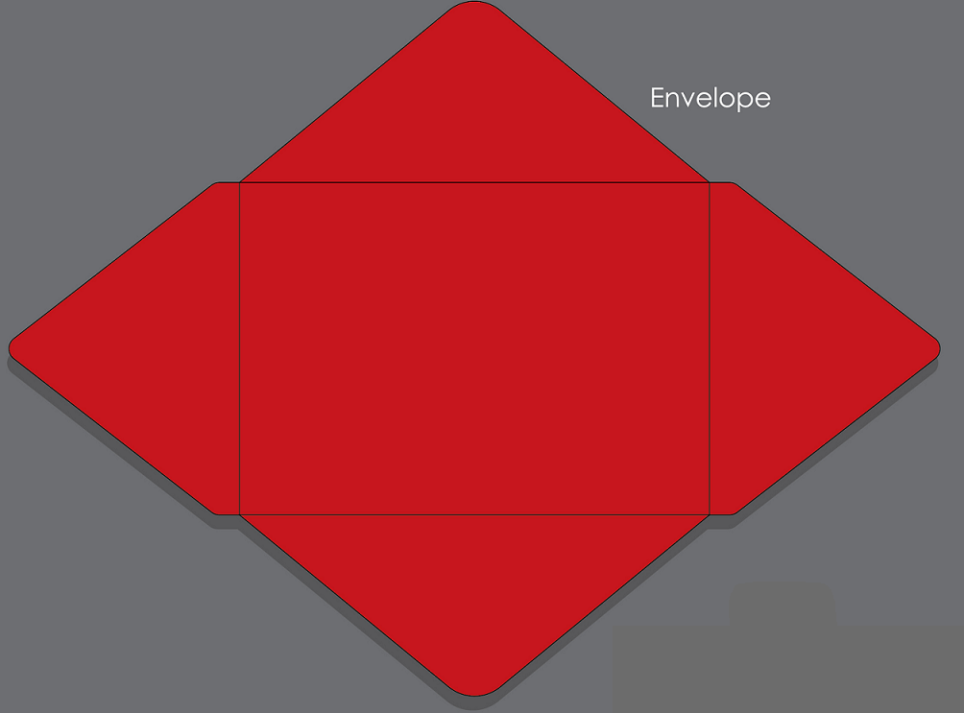

**E. Decorate your envelope – draw your zodiac animal and cut-out and glue the corresponding Chinese character.**

**B. Fold 1 and 2 and then glue or tape them.**

**C. Fold 3 and then glue or tape on the folded parts (1 and 2).**

**D. Fold 4 and insert between the other parts (1/2/3).**

**A.Cut-out the template onto red paper.**



